**CSS Class Exercises**

## Excercise 1. Text format.

Create a HTML document from the scratch with your CV. Create a CSS style sheet called MyStyle.CSS with the followings requirements.

## Normal text: Arial, color black, size 16px.

Nota: Podemos usar div con la propiedad float: left si queremos dos columnas:

<https://www.w3schools.com/css/css_website_layout.asp>

Nota2: Para centrar un div, podemos usar el código mostrado:

<https://www.w3schools.com/css/css_align.asp>

|  |
| --- |
| <!DOCTYPE html>  <html lang="en">  <head>  <title>CSS Website Layout</title>  <meta charset="utf-8">  <meta name="viewport" content="width=device-width, initial-scale=1">  <style>  * {  box-sizing: border-box;  }  body {  margin: 0;  }  .center {  margin: auto;  width: 90%;  border: 1px solid black;  overflow: auto;  }  /* Style the header */  .header {  color: blue;  background-color: #f1f1f1;  text-align: center;  padding: 10px;  }  .sectionheader {  text-align: left;  padding: 10px;  color: darkred;  }  .data {  text-align: left;  padding: 10px;  }  /* Create three unequal columns that floats next to each other */  .column1 {  float: left;  padding: 10px;  width: 30%;  font-weight: bold;  }  .column2 {  float: left;  padding: 10px;  width: 70%;  }  /* Responsive layout - makes the three columns stack on top of each other instead of next to each other */  @media screen and (max-width: 600px) {  .column1, column2 {  width: 100%;  }  }  </style>  </head>  <body>  <div class="center">  <div class="header">  <h1>CURRICULUM</h1>  <h1>VITAE</h1>  </div>  <div class="sectionheader">  <h1>PERSONAL DATA</h1>  </div>  <div class="data">  <p>Name: </p>  <p>Surname: </p>  <p>Date of Birth: </p>  </div>  <div class="sectionheader">  <h1>EDUCATION</h1>  </div>  <div class="column1">  <p>2017-2019</p>  </div>  <div class="column2">  <p>ASIR (La Marisma)</p>  </div>  <div class="column1">  <p>2015-2017</p>  </div>  <div class="column2">  <p>Bachillerato (La Marisma)</p>  </div>  <div class="sectionheader">  <h1>EDUCATION</h1>  </div>  <div class="column1">  <p>2017-2019</p>  </div>  <div class="column2">  <p>Técnico informático (IT Systems)</p>  </div>  <div class="column1">  <p>2015-2017</p>  </div>  <div class="column2">  <p>Asistente técnico (Bell)</p>  </div>  </div>  </body>  </html> |

## Exercise 2: CSS Layouts

In this exercise you will have an opportunity to work through the challenges of laying out a web page using CSS. You will begin with the HTML file that will appear as the one on the left and add all required HTML and CSS to produce the layout on the right.

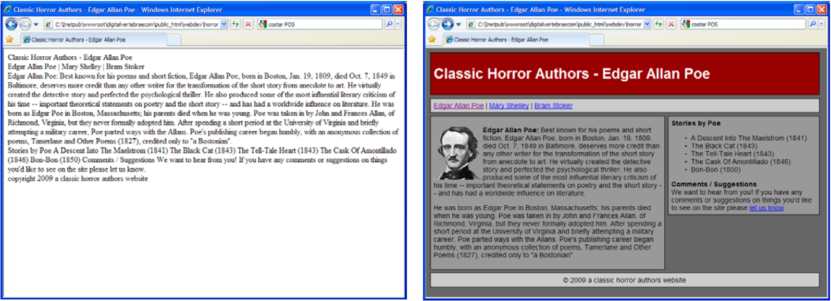

Download the exercise files [here](https://docs.google.com/open?id=0B0rsR4nWxyZZY2dxOTdieUk5cjg).

|  |  |
| --- | --- |
| **Here are some additional details:**  1. Divide the content using div tags into:  a. Header  b. Navigation  c. Content  d. Rightpanel  e. Footer  2. The overall page should:  a. Have a Background color set to 666666  b. Use the font families Arial, Helvetica, Sans-Serif  c. Have a font size of 90%  3. All divs should:  a. Have a top margin of 6 pixels  b. Padding of 6 pixels  c. A 1 pixel solid black border  4. The header div should:  a. Have a background color of 990000  b. Have a width of 779 pixels | 5. The navigation div should:  a. Have a background color of CCCCCC  b. Have a width of 779 pixels  6. The footer div should:  a. Have a background color of CCCCCC  b. Have a width of 779 pixels  c. Have a text alignment set to center  d. Use a style of **clear:left** (this will be new to you)  7. The content div should:  a. Have a background color of 999999  b. Have a width of 464 pixels  c. Have a bottom margin of 6 pixels  d. Float to the left of the rightpanel div  8. The rightpanel div should:  a. Have a background color of 999999  b. Have a width of 295 pixels  c. Have a left margin of 484 pixels |

In the Comments/Suggestions area the text ‘let us know’ should have an email link. Use any email address. For the hyperlinks in the navigation, use poe.html, shelley.html and stoker.html respectively.

*Exercise 3. Styling Links*

Create a website for your curriculum vitae. You must use a two‐column layout and the second column must be the navigation bar styling with boxes.

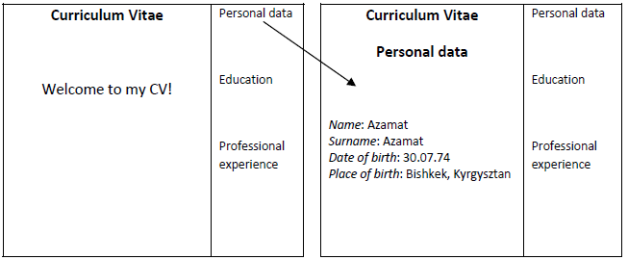

*Excercise 4. Styling Tables.*

Modify the code at [W3Schools](http://www.w3schools.com/css/tryit.asp?filename=trycss_table_caption-side) to get the following table.

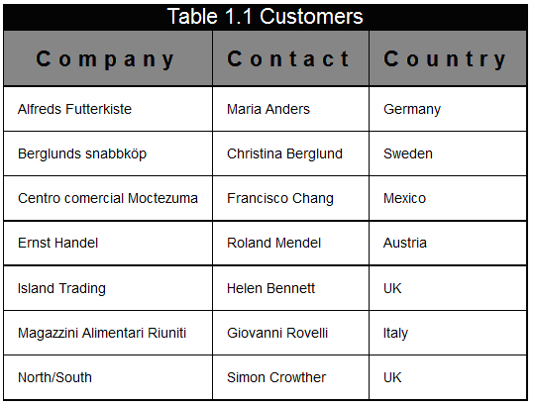

*Exercise 5. Styling Tables.*

Create a table. Style your color table so that it looks like this:

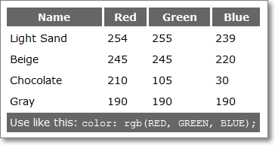

*Exercise 6,7, 8. Absolute position*

**Posicionamiento absoluto**

Usa posicionamiento absoluto y resuelve los siguientes ejercicios

<https://www.mclibre.org/consultar/htmlcss/ejercicios/posicionamiento-absoluto/coordenadas/coordenadas-2.html>

Una posible solución al primer ejercicio es:

|  |
| --- |
| <!DOCTYPE html>  <html>  <head>  <style>  #main {  position: absolute;  width: 500px;  height: 300px;  background-color: lightgray;  }  p {  font-family: sans-serif;  font-size: 300%;  margin: 0;  }  /* MODIFIQUE LAS PROPIEDADES SIGUIENTES: */  p#p1{  position: absolute;  top: 10px;  left: 10px;  width: 200px;  height: 50px;  background-color: red;  }  p#p2{  position: absolute;  bottom: 10px;  right: 10px;  width: 200px;  height: 70px;  background-color: blue;  }  p#p3{  position: absolute;  bottom: 10px;  left: 10px;  width: 200px;  height: 100px;  background-color: green;  }  p#p4{  position: absolute;  top: 10px;  right: 10px;  width: 200px;  height: 100px;  background-color: yellow;  }  </style>  </head>  <body>  <div id="main">  <p id="p1">1</p>  <p id="p2">2</p>  <p id="p3">3</p>  <p id="p4">4</p>  </div>  </body>  </html> |

Mira el siguiente ejercicio y comprueba cómo se resuelve

<https://www.mclibre.org/consultar/htmlcss/ejercicios/posicionamiento-absoluto/murphy/murphy-1-formateado.html>

*Exercise 9. Flexbox*

Usa flexbox y resuelve los siguientes 3 primeros ejercicios

<https://www.mclibre.org/consultar/htmlcss/ejercicios/flexbox/frutas/frutas.html>